Advance contact search
(DOCUMENTATION)

Title: ADVANCE CONTACT SEARCH

ROLL No | NAME
2251-10-737-081 K.Siddhartha

GUIDE: P Karthik

Project Duration: 16 July 2012 to 08 Oct 2012

B.E 3/4 IT 1Semester
Department of Information Technology

M.V.S.R Engineering College

Students’ Request for Guide

We, the students of 3/4 1 Sem. IT here by request you to guide our Mini Project,

“ ADVANCE CONTACT SEARCH “.

S.No Names Roll Nos

- K.Siddhartha 2451-10-737-081

- B.Pranay 2451-10-737-080

- Mohammed Ali 2451-10-737-086

Guide’s Consent

I , Mr. P Karthik , here by give my consent to guide the Mini Project
“ ADVANCE CONTACT SEARCH “ ,
with a batch of students that made a request above.

Date: 30-7-2012
NameP Kart hik
Designation: Asst Professor
Department of Information Technology

Title: ADVANCE CONTACT SEARCH

Statement of Problem:
Generally most of the contact search will provide option search only by name, so we provide a search in contacts for skills and their occupation by which user can make effective search of the resources provided to him

Scope of work:
- Creation of contact search app for android
- Use of eclipse software to develop app
- Java language for business logic
- Xml pages for layout

Guide’s Signature and Date

content
- NAME
- SYSTEM REQUIREMENTS
- HOW TO OPEN THE GAME
- SAMPLE OUTPUT
- REFERENCES
- AUTHOR, COPYRIGHT, LICENSE

NAME
ADVANCE CONTACT SEARCH – an android application created to search contacts in a easy way .

SYSTEM REQUIREMENTS

1-android OS supporting device from 2.1 onwards

HOW TO INSTALL/OPEN APPLICATION
1. Load the advcontact.apk file given in this document folder into sdcard of your phone.
2. Find the advcontact.apk in ur sd card of phone and click on it.
3. Then press install all on to the divice.
4. Run application

SAMPLE OUTPUT

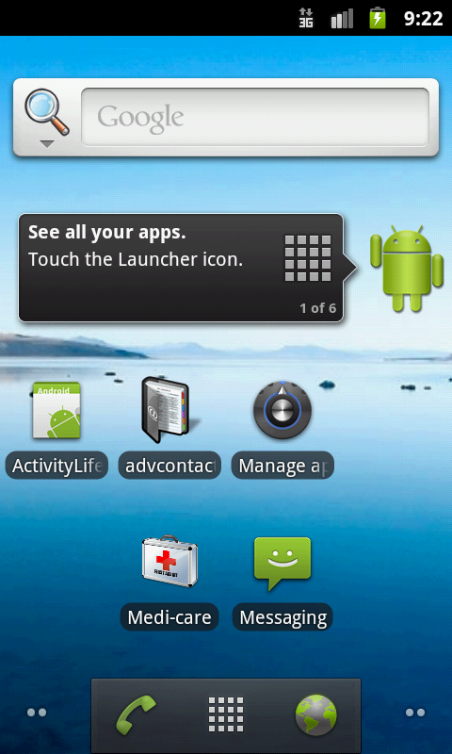

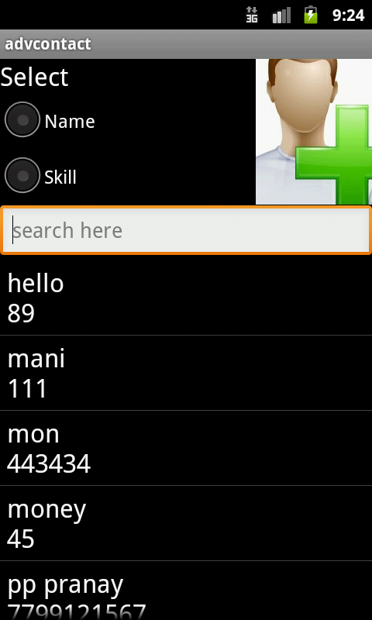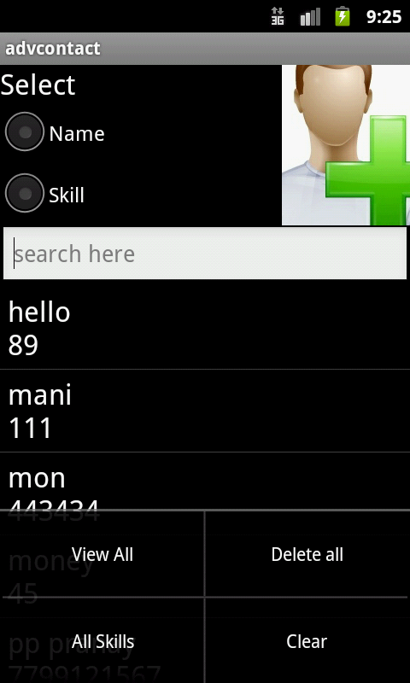
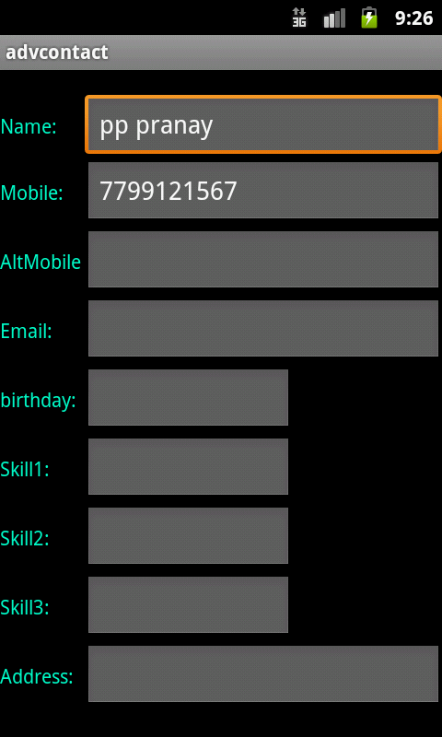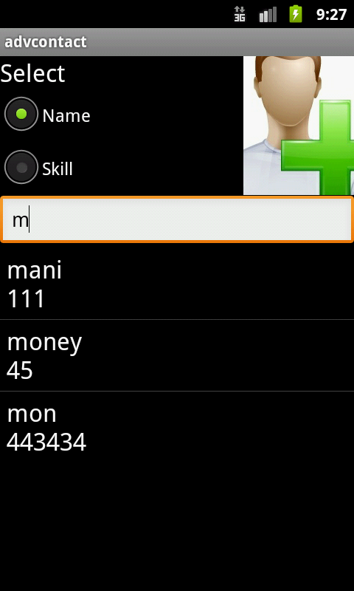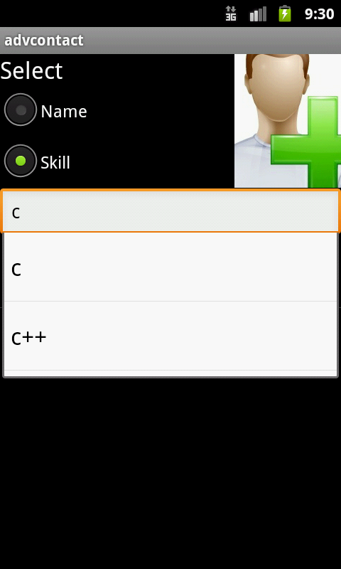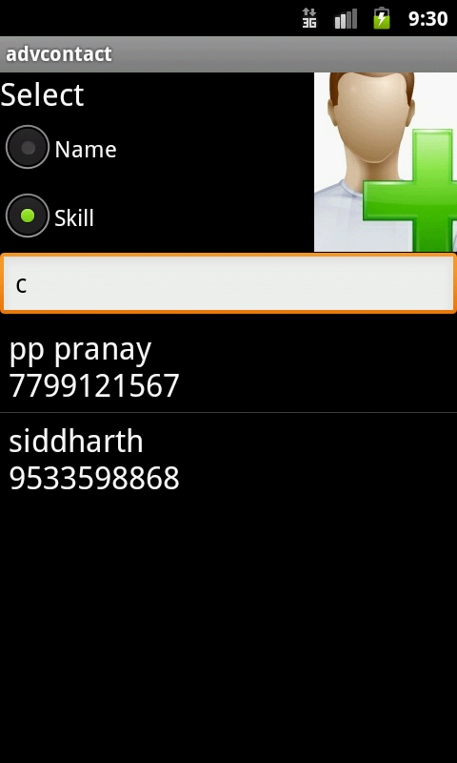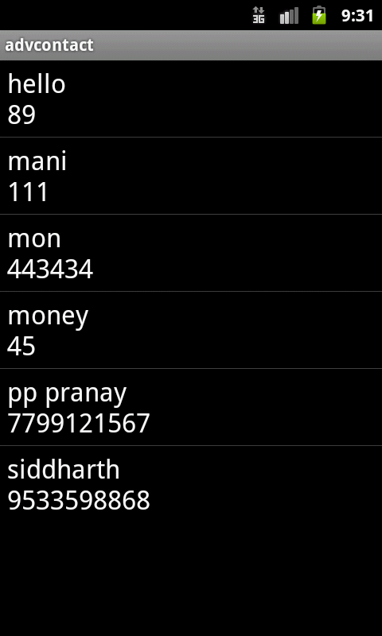

REFERENCE

1

2

3

4

5

AUTHOR, COPYRIGHT, LICENSE
K.SIDDHARTHA
B.PRANAY
MOHAMMED ALI
Copyright 2012,
This is free software; you can redistribute it/or modify it.

